Andy Ni

COMP 3710

Assignment 6

1. User runs the app and UI pops up with the database information so far inputted, clicking on Search Transaction History brings up the Search UI.

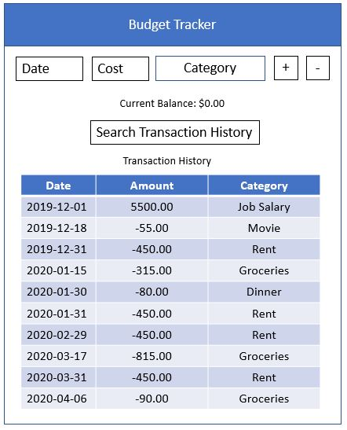

1. Search UI, allowing users to enter in a range of dates, range of values, and if the transactions were income or expenses using checkboxes. Clicking on Search without inputting anything at the start will pull up all transactions.

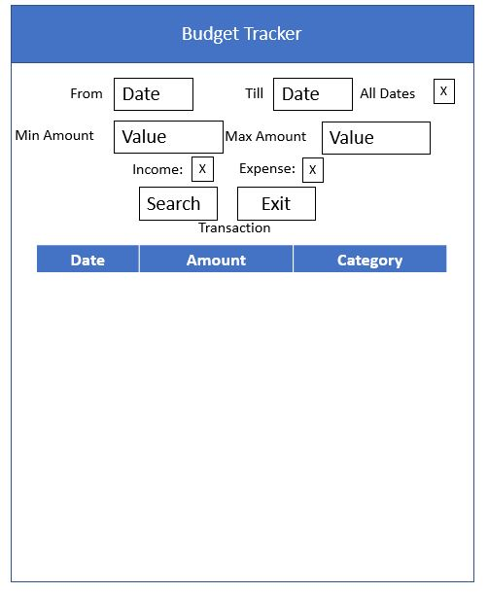

1. All transactions shown on UI now

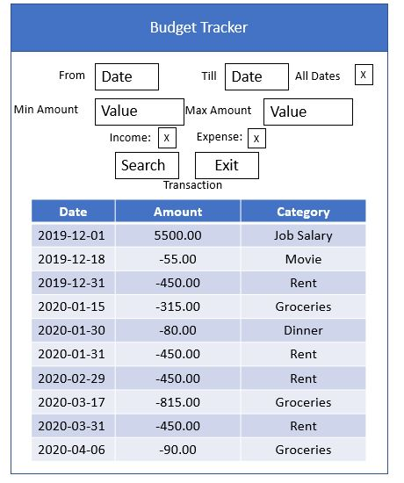

1. User enters new search for all transactions since Jan 1, 2020 by entering the from date and using the today date as the till date. User must uncheck the all dates checkbox and then click search.

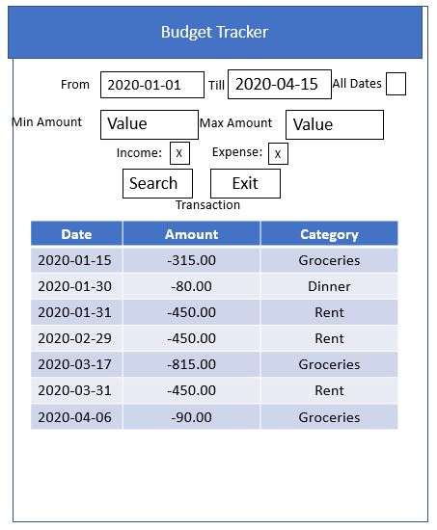

1. User enters new search for all adding transactions between Jan 1, 2020 and Mar 31, 2020. User unchecks all dates and expenses to search for only adding transactions between the range of dates given.

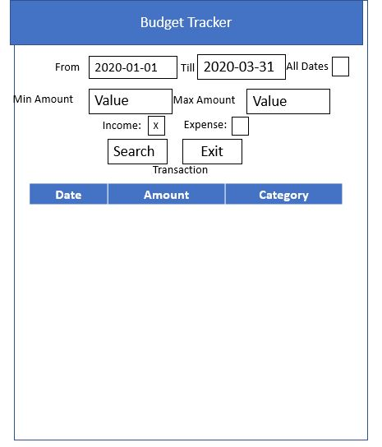

1. User enters new search for all spending transactions between Jan 1, 2020 and Mar 31, 2020 with amount >= $100. User unchecks the income box and makes sure the expense box is checked and clicks search after entering the min amount and not entering a max.

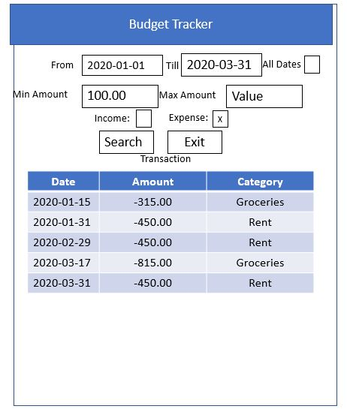

1. User enters new search for all spending transactions between Jan 1, 2020 and Mar 31, 2020 with amount >= $100 and <= $500.

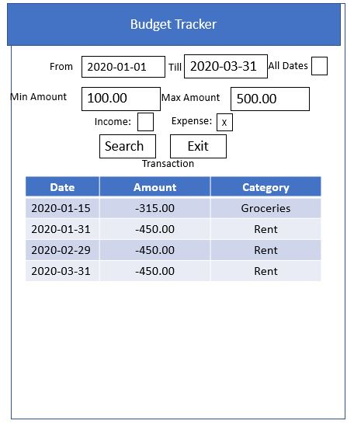

1. User enters new search for all adding transactions with amount >= $1000.

